Ideation Phase Brainstorm & Idea Prioritization

|  |  |
| --- | --- |
| Date | 22 October 2022 |
| Team ID | PNT2022TMID29475 |
| Project Name | Emerging methods for early detection of forest fires |
| Maximum Marks | 4Marks |

Step-1:Problem statement

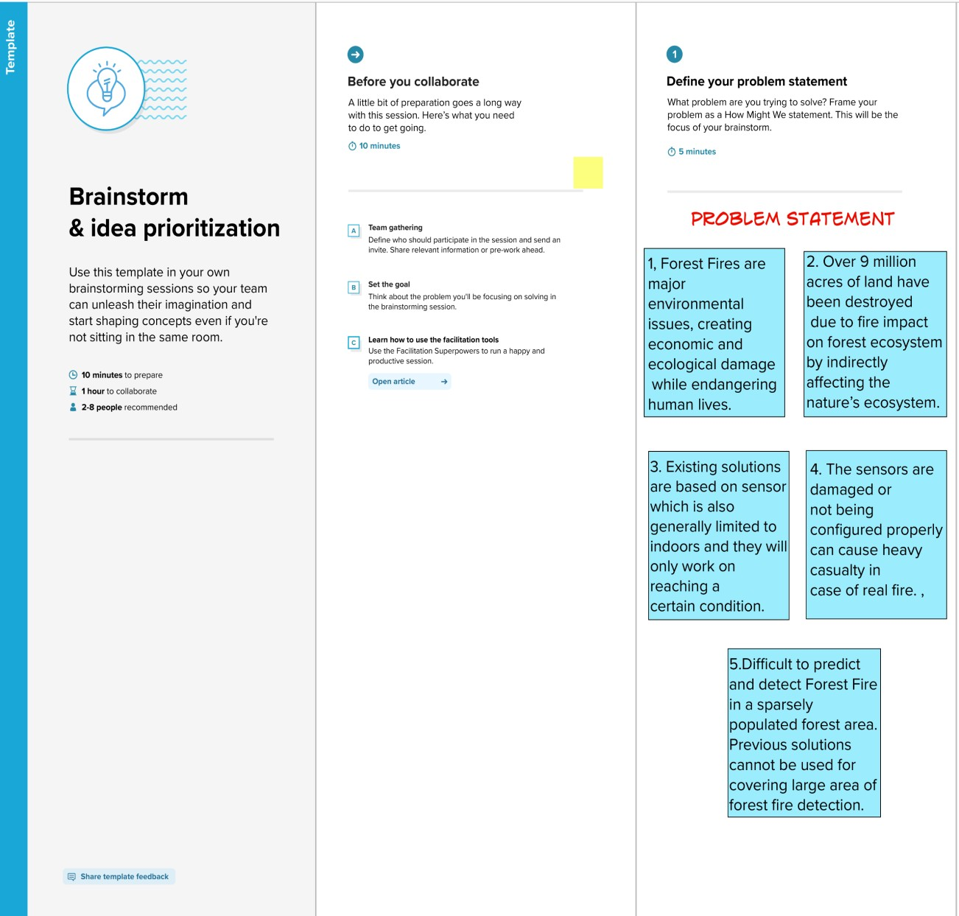

Step-2: Brainstorm,Idea,Listing and Grouping

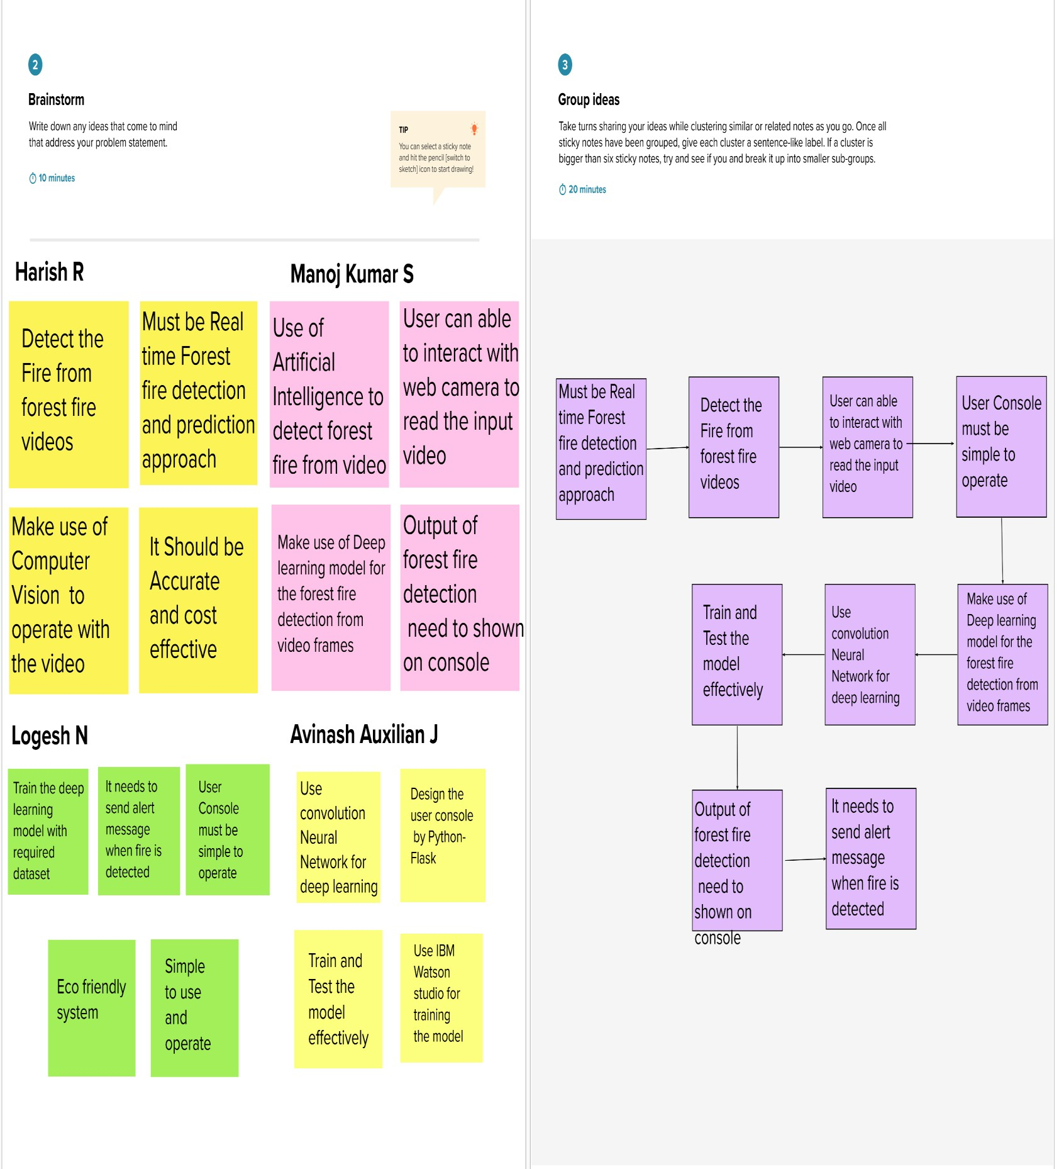

**Harish k**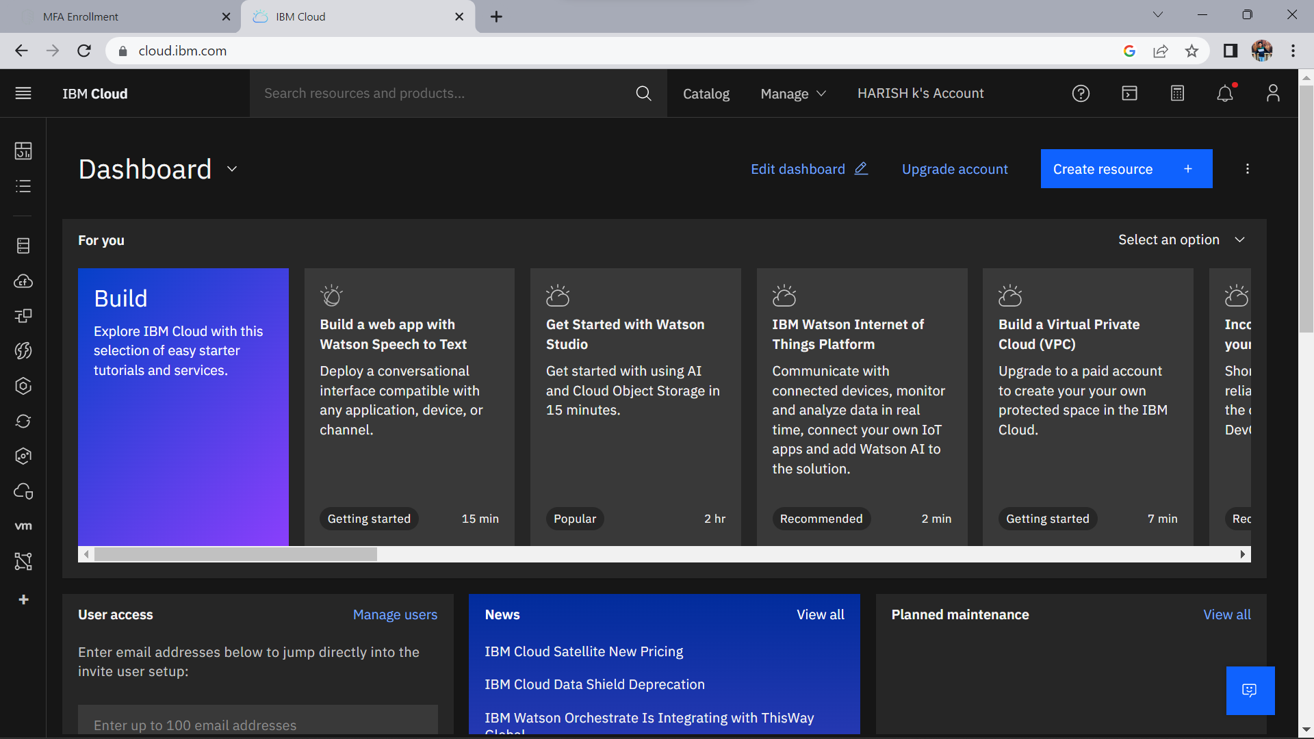

**Siva kumar R**

Step-3: Idea Prioritization

**Sujith S**

**Manikandan N**

Step-3: Idea Prioritization

